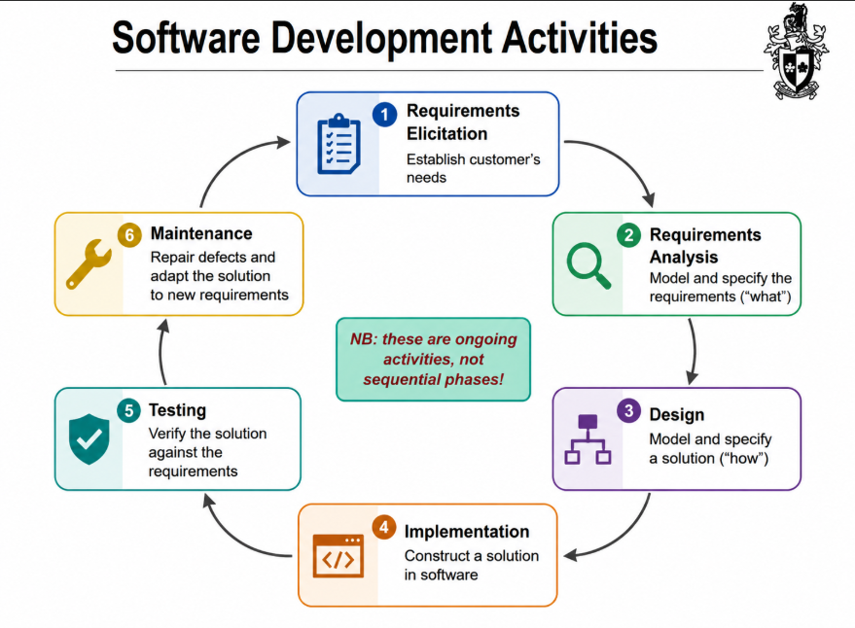
B. What drives software development?
- Software systems are created mainly to achieve business goals. Common motivations include:
+ Retaining ot increasing customers
+ Improving customer relationships
+ Increasing productivity and efficiency
+ Replacing outdated technology
+ Resonsding to legal or social changes.
- Business goals generally fall into five categories:
+ Reduce ownership cost
+ Improve system quality
+ Improve system functionality
+ Improve market position
+ Improve external confidence

- Stakeholders and Conflict Views
Different stakeholders have different priorities including customers, developers, managers, and users. There perspectives may conflict, so software development approaches must balance varying expectations and trade-offs.

- Functional and Non-Functional Requirement
- Functional Requirement: Describes what the system does
- Non-functional Requirement: Describe constraits or qualities of the system such as performance, reliability, security, maintainbility, deployment cost.
- Types of Non-functional requirement: Product requirement (related to system behavior such as speed and reliability), organizational requirement (derived from company standards or policies), and external requirements (related to laws, regulations).

- Verification and Validation
- Verification: ‘Are we building the product right’ => Checks whether the software conforms to specifications
- Validation: ‘Are we building the right product’ => Checks whether the software satisfies stakeholder needs

- What is Software Design?
- Design as a creative activity
- Design as the resulting artefact/documentation
- Design determines: Components, Interface, and System Structure.

- Decompositions and Models
- Decomposition: divide-and-conquer technique used to manage complexity by breaking systems into smaller parts.
- Models: simplify reality to improve understanding. They may represent: Structure (static models) and Behavior (dynamic models) => Examples: UML, Wireframes

